COMP 3270 Introduction to Algorithms Homework 3

Homework 3

**Radix Sort**

1. If Radix Sort is applied to the array of numbers [4567, 3210, 2345, 4321, 5678], show how these numbers will get rearranged after each of the four passes of the algorithm.
   1. Step 1: 0’s position

|  |  |  |  |  |  |  |  |  |  |
| --- | --- | --- | --- | --- | --- | --- | --- | --- | --- |
| 0 | 1 | 2 | 3 | 4 | 5 | 6 | 7 | 8 | 9 |
| 3210 | 4321 |  |  |  | 2345 |  | 4567 | 5678 |  |

3210, 4321, 2345, 4567, 5678

* 1. Step 2: 10s position

|  |  |  |  |  |  |  |  |  |  |
| --- | --- | --- | --- | --- | --- | --- | --- | --- | --- |
| 0 | 1 | 2 | 3 | 4 | 5 | 6 | 7 | 8 | 9 |
|  | 3210 | 4321 |  | 2345 |  | 4567 | 5678 |  |  |

3210, 4321, 2345, 4567, 5678

* 1. Step 3: 100s position

|  |  |  |  |  |  |  |  |  |  |
| --- | --- | --- | --- | --- | --- | --- | --- | --- | --- |
| 0 | 1 | 2 | 3 | 4 | 5 | 6 | 7 | 8 | 9 |
|  |  | 3210 | 2345/4321 |  | 4567 | 5678 |  |  |  |

3210, 4321, 2345, 4567, 5678

* 1. Step 4: 1000s position

|  |  |  |  |  |  |  |  |  |  |
| --- | --- | --- | --- | --- | --- | --- | --- | --- | --- |
| 0 | 1 | 2 | 3 | 4 | 5 | 6 | 7 | 8 | 9 |
|  |  | 2345 | 3210 | 4567/4321 | 5678 |  |  |  |  |

2345, 3210, 4321, 4567, 5678

**Divide and Conquer & Algorithm Design**

1. Consider the following algorithm:

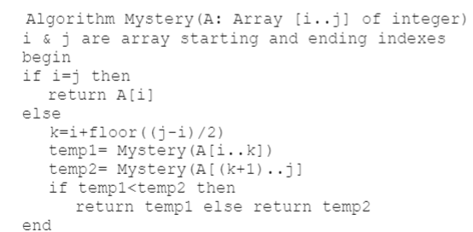

What does the recursive algorithm above compute?

Finds out the largest element present in the array and returns it after it terminates.

**Adjacency Matrix**

1. Represent the follow graph using its adjacency matrix. The number in the circle indicates the corresponding index of the node.

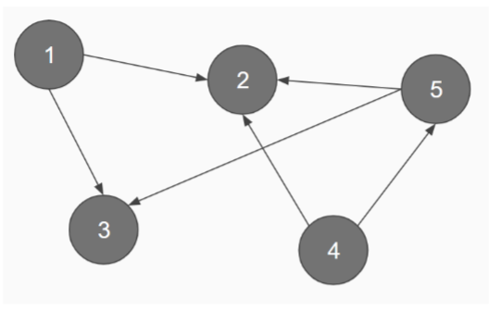

**Adjacency matrix**

|  |  |  |  |  |  |
| --- | --- | --- | --- | --- | --- |
| **0** | **1** | **2** | **3** | **4** | **5** |
| **1** | 0 | 1 | 1 | 0 | 0 |
| **2** | 0 | 0 | 0 | 0 | 0 |
| **3** | 0 | 0 | 0 | 0 | 0 |
| **4** | 0 | 1 | 0 | 0 | 1 |
| **5** | 0 | 1 | 1 | 0 | 0 |

**Prim's Algorithm / MST**

1. Rule out the MST of the following graph using Prim’s algorithm. The number in the circle indicates the corresponding index of the node, while the numbers on the edges are their weights. **Use node 0 as the starting node. You must show your work.**

